Windchill Stop and Start Shortcuts on Desktop
Schindler CRD Applications

Exported on 2025-08-19 06:21:11

Table of Contents

1 Prerequisite: 4
2 Procedure: 5

- Prerequisite:
- Procedure:

Prerequisite:
- Windchill should be installed on Target server.
- Apache and Windchill services should be available on Windows services.

Procedure:
- Copy/paste the below folder with contents from Source Windchill 12 server to Target Windchill 13 server.
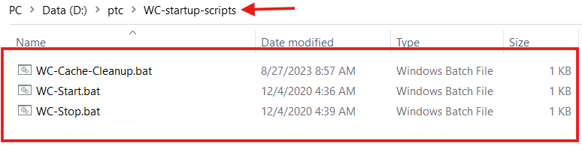

2. Below are the contents of the above .bat files.
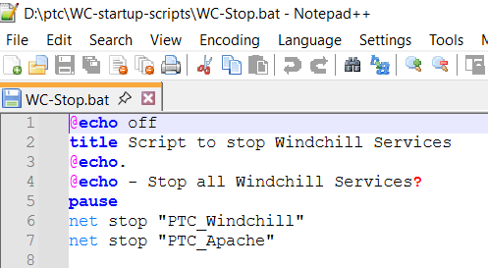

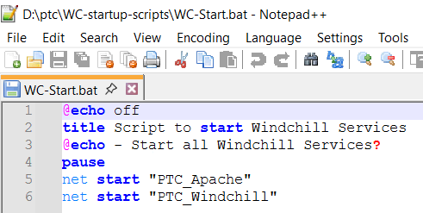

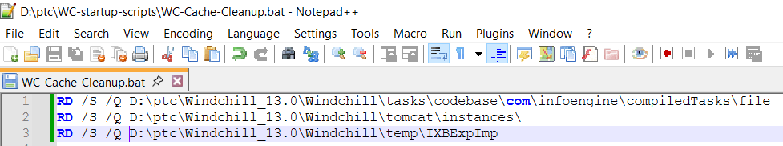

3. Please make sure the windows services were added with name as shown in the above screenshots.
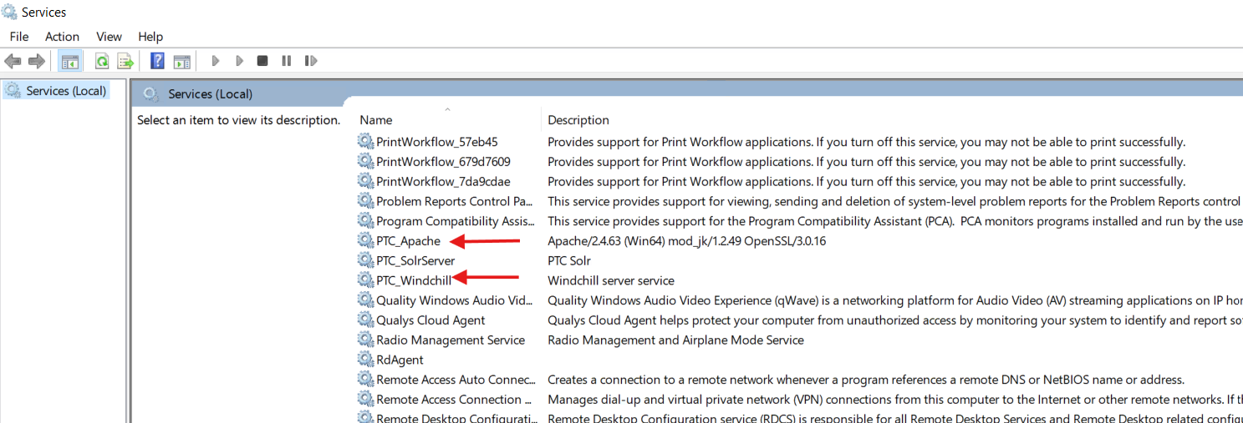

4. Right click and create the shortcuts for below three .bat files.
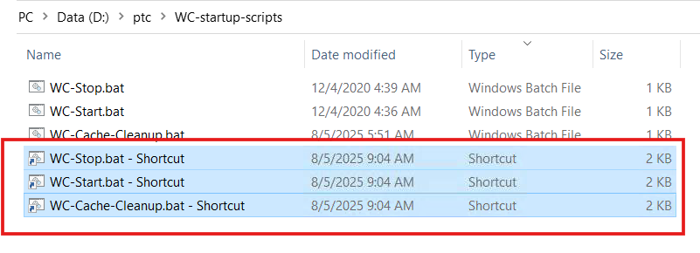
5. Cut and paste the above shortcuts to the below location.
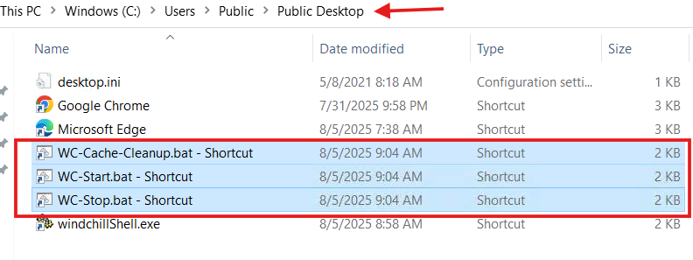

6. Rename the shortcuts as shown below.
